Sense-U Smart Breast Pump: User Manual

# READ ME FIRST

**IMG_256DANGER**-To reduce the risk of electrocution:****

1. Do not use while bathing.
2. Do not place or store product where it can fall or be pulled into a tub or sink.
3. Do not place in or drop into water or other liquid.
4. Do not reach for a product that has fallen into water. Unplug immediately.
5. Always disconnect from the charger before using it.

**IMG_257WARNING**-To reduce the risk of burns, electrocution, fire, or personal injury.****• Do not modify the product.

1. Do not use attachments not recommended by the manufacturer.
2. Never operate this product if it has a damaged cord or plug, if it is not working properly, if it has been  dropped or damaged, or dropped into water. Return the product to a service center for examination and repair.
3. Keep the cord away from heated surfaces.
4. Never use while sleeping or drowsy.
5. This is not a toy, keep it out of the reach of children.
6. This is a personal care product for a single user and should not be shared between users.
7. If irritation or discomfort occurs, use your finger to break the seal between the flange and the breast  tissue, discontinue use and see a healthcare provider.
8. Do not wear and use the product for over 35 minutes. Consult your healthcare practitioner to understand how long you should pump in a pumping session.
9. Do not wash or sanitize the pump hub. Wipe with clean, damp cloth only.
10. Do not place the breast pump in refrigerator or freezer. Do not use a microwave oven.
11. Do not boil the milk container and all the silicone parts for more than 5 minutes every time.
12. Do not use the product in an environment that is too hot or too cold, never expose the product to  strong sunlight or a humid environment.

# PRODUCT OVERVIEW

## What's In the Box

****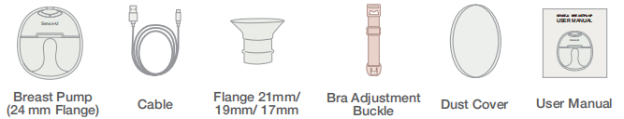****

## LED Display and Buttons

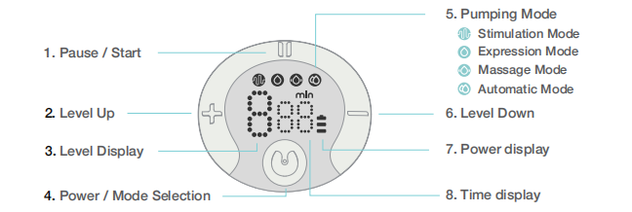

****Notice****This product has a built-in lithium battery. When the battery level indicator flashes, please charge the console as soon as possible with a certified 5V 1A power adapter.

# HOW TO ASSEMBLE A BREAST PUMP

## CAUTIONS

1. Make sure that you assemble the pump correctly as instructed in this user manual.
2. To avoid leakage, remove the residue around the rim before assembling.
3. Wash your hands thoroughly before you assemble cleaned components. direction to lock it in position.

****STEP 1:**** Install the valve to the milk collector, pay attention to the direction of installation.

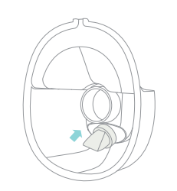

****STEP 2****: Put the silicone diaphragm into the milk collector, and press it with your hands to make the edges fasten tightly to ensure a perfect seal.

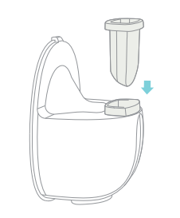

****STEP 3****: To install the flange on milk collector, make sure to align the diversion groove on the flange with the backflow groove on the milk collector, and then press the edges with both hands to ensure the seal is in place.

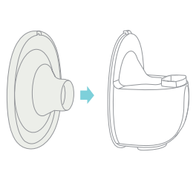

****STEP 4****: Install the main body of the breast pump on the milk collector, align the notch under the main body with the silicone diaphragm, and assemble it downward to fit the milk collector to ensure a complete seal.

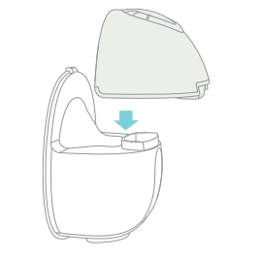

\* The breast pump does not work in charging mode.

# BEGINNING PUMPING

1. Press the flange firmly against the breast, leave no gaps and make sure your nipples are centered. Keep it upright. Be careful not to distort the position of the product and the chest, otherwise the breast pump will not have suction.

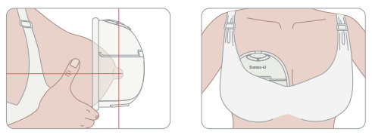

2. Long press the "IMG_265"button to start the breast pump.

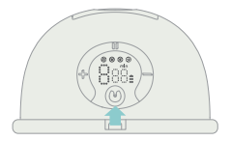

## Tips:

1. This model has a built-in memory function. When you turn on the machine again, it automatically enters and shifts up to the working mode and suction level you used last time.
2. The breast pump will automatically stop after 20 minutes of operation.

3. You can briefly press the "IMG_267 " button to start or pause the breast pump. Similarly, pressing the "IMG_268 " button quickly switches modes after starting the pump. When " IMG_269" is displayed, it signifies stimulation mode; "IMG_270 " indicates expression mode; "IMG_271 " signals massage mode, and "IMG_272 " denotes automatic mode.

4. There are 9 levels in each mode. You can choose the suction level that makes you comfortable by briefly pressing the "IMG_273 " button to increase the level and the " IMG_274" button to decrease it.

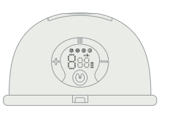

1. Breastfeeding sitting position, relax and sit in a comfortable chair, leaning slightly forward (use a cushion for back support). Make sure to keep the breast pump and breast cup upright.

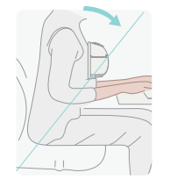

# FINISHING PUMPING

1. When you have finished expressing, long-press the"IMG_277"button to switch off and break the seal between the breast and the pump funnel with your finger, and then carefully remove the pump from your breast.

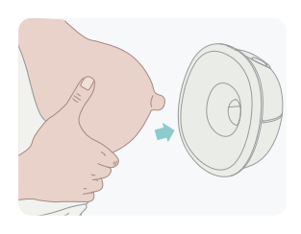

# Separate the milk collector from the pump motor to prepare for feeding or storage. Clean the other used parts according to the instructions.

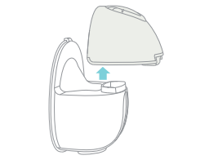

# Pour the milk into the storage bottle, ensuring that the slot feature aligns with t he bottle opening.

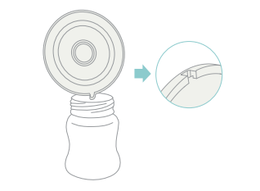

# OPERATION

## Download the Sense-U App

1. Download the free Sense-U Baby App, available for iOS and Android from Apple App Store and Google Play.
2. Follow the in-app instructions to pair the Sense-U Device accordingly.



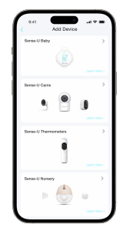         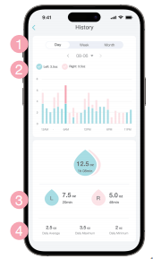

## Sense-U App at a Glance

1. ****Day/ Week /Month:****Time records by day, week, and month
2. Bar chart of total milk volume for the left and right sides
3. ****L/ R:****Record of single pumping volume and duration for the left and right sides
4. Daily milk volume analysis

# 10CLEANING & MAINTENANCE

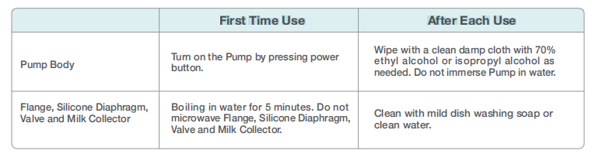

## Cleaning by Hand

1. Place pump parts in a clean wash basin used only for infant feeding items. Do not place pump parts directly in the sink.
2. Add soap and hot water to the basin.
3. Scrub items using a clean brush designated solely for infant feeding items.
4. Rinse by holding items under running water or by submerging them in fresh water in a separate basin.
5. Air-dry thoroughly. Place pump parts, wash basin, and bottle brush on a clean, unused dish towel or paper towel in an area protected from dirt and dust. Do not use a dish towel to rub or pat items dry.
6. Clean the wash basin and bottle brush. Rinse them well and allow them to air-dry after each use. Wash them by hand at least every few days.

IMG_285****WARNING****

1. Be careful when removing and cleaning the valve. If the valve is damaged, the breast pump will not work properly.
2. To clean the valve, please rub it gently in warm water with a few drops of cleaning liquid. Do not insert any objects into the valve, as this may cause damage.
3. Make sure to clean the pump as instructed in this user manual.

# BRA STRAP ADJUSTMENT

1. Adjust the length of the bra straps to make them more comfortable.

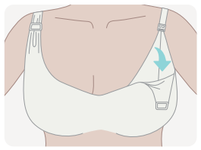

1. Hang one end of the bra adjustment buckle on the inside buckle of the nursing bra.

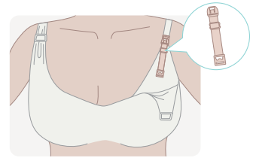

1. Adjust the length of the bra straps using the other end of the bra adjustment buckle.

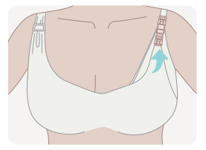

# BATTERY STATUS INDICATOR

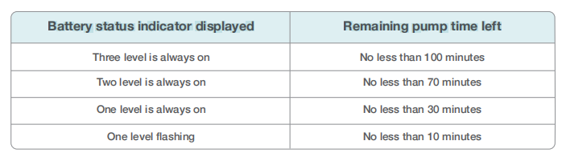

# STORING YOUR BREAST MILK

## Storing Breast Milk

1. Only store breast milk collected by sterilized breast pumps.
2. The extracted milk can be placed in a clean and sterilized milk storage bag or a milk bottle with a sealing cushion, and immediately placed in the refrigerator to refrigerate or freeze.

## Breast Milk Cold Storage

1. Do not freeze breast milk repeatedly.
2. Do not mix fresh breast milk with frozen breast milk.
3. Be sure to discard the breast milk left after feeding.
4. The extracted milk can be refrigerated in the refrigerator for 48 hours (inside the refrigerator) or frozen in the freezer for three months, and the milk bottle or milk storage bag can be affixed with a label clearly marking the milking date and time.

## Unfreeze Breast Milk

Place the frozen breast milk in the refrigerator compartment for one night to thaw. In an emergency, you can use a bowl of hot water to thaw breast milk. After thawing breast milk, it must be consumed within 24 hours.

## Heating Breast Milk

1. Erect the baby bottle in a bowl of hot water or heat the breast milk safely and quickly with a baby bottle and food heater.
2. Keep in mind! Before feeding your baby, be sure to check the temperature of breast milk.
3. Do not use a microwave oven to heat breast milk because this may destroy important nutrients and antibodies.
4. In addition, uneven heating may cause partial overheating of the liquid, which may cause burns.
5. Do not immerse the milk storage bottle in boiling water to heat it to prevent it from rupturing or cracking.

****Product Name:****Sense-U Wearable Breast Pump

****Model:**** S32

****Battery:****1000mAh Li-ion Rechargeable Battery

****Charging Interface:**** Type-C

****Product Net Weight:**** 8.5oz (241g)

****Product Size:****4.96"x4.45"x2.72" (126mmx113mmx69mm)

\* Caution: Do not immerse the pump motor in liquid

# DISCLAIMER

The Sense-U breast pump is not a medical device and is not intended for use in the diagnosis of disease or other conditions, or in the cure, mitigation, treatment, or prevention of disease. Customers use this product at their own risk and Sense-U Inc., its members, employees, agents, contractors, representatives, manufacturers, distributors and associates shall not be held liable for any loss, damage or injury suffered by the customer or any other person arising from, or in connection with, the use or manufacture of the product, including loss, damage or injury suffered by the customer or any other person as a result of any defects in respect of the product, and all warranties, and any other liability from whatsoever cause arising, are hereby excluded and the customer hereby indemnifies Sense-U Inc. in respect of any such liability.

# GUARANTEE

Sense-U promises a 30-day Money Back Guarantee for this product and a 1-year Limited Warranty from the original date of purchase, verified by a sales receipt. Our warranty liability shall be limited to replacing the unit free of charge and does not include transport costs. Our guarantee extends to all countries in which this product is supplied. By the act of operating this product, the user accepts all resulting liability. We reserve the right to modify the provisions of this guarantee at any time without notice. This guarantee does not cover the battery, incorrect application, tampering, misuse or transport damage.

# How to assemble a Breast Pump?

****STEP 1:**** Install the valve to the milk collector, pay attention to the direction of installation.

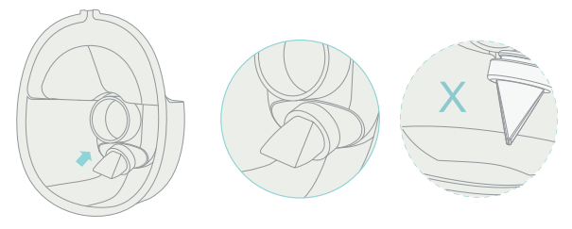

****STEP 2:**** Put the silicone diaphragm into the milk collector, and press it with your hands to make the edges fasten tightly to ensure a perfect seal.

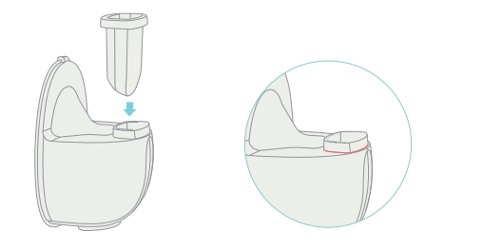

****STEP 3:**** To install the flange on milk collector, make sure to align the diversion groove on the flange with the backflow groove on the milk collector, and then press the edges with both hands to ensure the seal is in place.

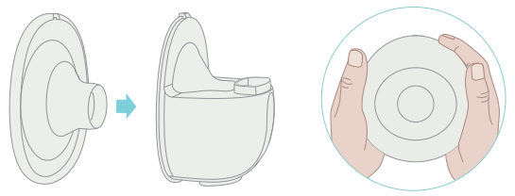

****STEP 4:**** Install the main body of the breast pump on the milk collector, align the notch under the main body with the silicone diaphragm, and assemble it downward to fit the milk collector to ensure a complete seal.

